**Department of Electrical and Computer Engineering**

**North South University**



**Senior Design Project**

Smart and compact electrical appliance management system through IoT (Internet of things) implementation, along with power regulation and monitoring features using high voltage semiconductor devices.

**Noor Al Din Ahmed 1310607043**

**Name 2 ID #**

**Faculty Advisor:**

**Tanzilur Rahman (Tnr)**

**EEE499A**

**Section:**

**Summer, 2017**

**Project Proposal**

**Title:**

Smart and compact electrical appliance management system through IoT (Internet of things) implementation, along with power regulation and monitoring features using high voltage semiconductor devices.

**Abstract:**

In today’s world everything is becoming modernized and almost everything is being controlled electronically and wirelessly. Keeping with the trend the world at present is seeing increased amounts of automation in homes. Home automation usually signifies increased automation of household appliances through electronic means. Although it is not as expensive as it used to be it is still quite costly and for that it has not been implemented at all in a developing country like ours. Hence we took on task of making a project which would involve automation of homes at a reasonable price with parts that are available within our country. Our project purpose is to build a unit that can monitor and control the electrical home appliances from anywhere in the world using a hand held mobile device. Nowadays, more and more people are getting easy access to the internet using a just simple handheld mobile device. And using it and the power of the internet people can always keep tabs on what appliances are running, what is the condition of a room and how much power is being consumed in that particular room, all in real time. In doing this project would be using concepts of microcontrollers, sensors, telecommunications and embedded programming.

**Aim and Objective:**

Our aim is to build a home automation system that will improve comfort, enhance accessibility, minimize operating costs, simplify use of technologies, and promote energy efficiency and convenience. We aim to build a system that will enable people who are out of their homes most of the time to monitor their homes in real time from anywhere in the world. Also the physically challenged people can easily control basic appliances through an already available cell phone using an application. Our system can be used in hospitals to manage certain room conditions.

**Motivation:**

Home automation results in a smarter home and is used to provide a higher and healthier standard of living. The beauty of home automation system is that it is highly scalable, flexible, easy to use and its capabilities are limited only by our imagination. The system will be integrated with other IoT devices and our motivation is to facilitate the users to automate their home having remote access to the appliances and allowing home security.

**Current status:**

Home automation is current used at thousands of homes if not millions, mostly popular in western civilizations. So far, the most popular way of implementing a home automation system is by using microcontrollers and AVRs for the processing part and Dual Tone Modulation Frequency (DTMF), Bluetooth, GSM, RF based controllers such as Zigbee or XBee, WI-FI or Ethernet. Of which few of them are operated through cloud based computing connected to the Internet of things (IoT). Their functionality and focus are in certain fields such as controlling door locks, detecting human presence, controlling various household appliances and providing various security features.

**Plan of work:**

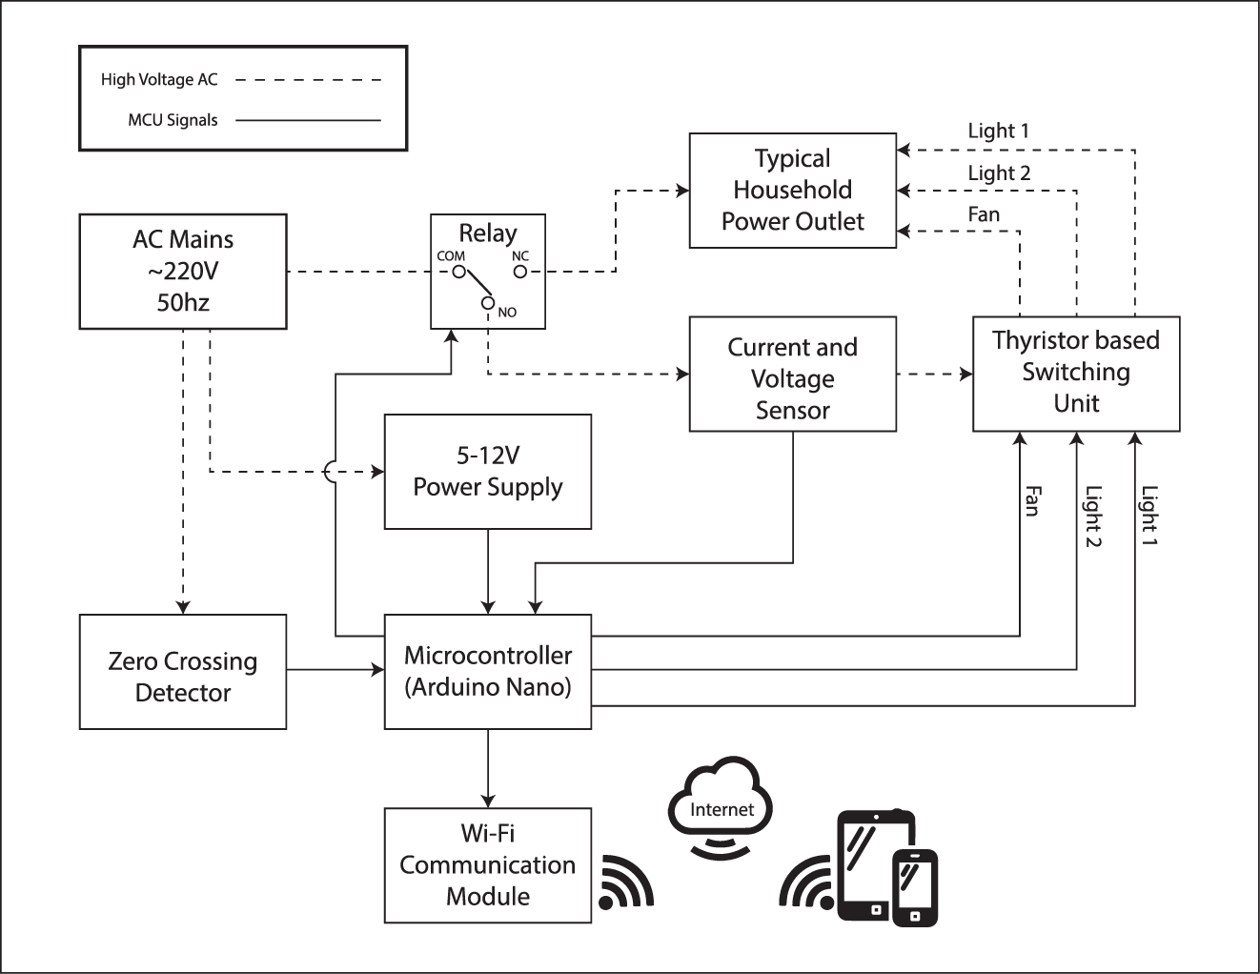

The device will be controlled through Wi-Fi in an indoor network hub that is connected to the internet. The system will be connected as follows: There will be a relay separating the Home Automation System from the traditional power outlet, so that we can switch between the traditional outlet and HAS anytime. The power outlet will be connected to the “Normally Closed” pin of the relay so that even if the HAS is turned off or not working the user can still use the traditional system. At “Normally Open” condition the HAS will be activated and the microcontroller will detect the phase of the AC signal through the Zero Crossing Detector (ZCD) and control the conduction cycle of the AC signal on the output of the Thyristor based switching unit. With the help of a ZCD, users can regulate the amount of power to output to the lights and Fan through the unit, besides having the capability of completely switching them on and off. The user will also know how much power is being consumed. The microcontroller will be connected to the user’s home internet connection through Wifi and can be controlled from anywhere around the world using an Android mobile application.

In order to make a web based Home Automation system, the following tasks need to be done:

**Software:**

1. Learning about XML – At the beginning, i will learn the basic terminology of XML. I need to gather general knowledge about XML and later, practice some tasks on XML.
2. Database – i will gather general idea about working on database, will learn to create basic SQL statements and then, will practice making a simple database.
3. Web Development – i will learn the essential coding skills needed to develop web applications. I will gather idea, practice and work on web development later.
4. Web Server – i will learn about a web server, will learn how a web server works and then i will try to make a simple web server. And based on the acquired knowledge from the practice, i will make a web server on home automation that will serve our purpose.
5. Test run – in the end, i will give the server a test run to check if it works according to our plan.

**Hardware:**

1. Simulating and Making the Zero crossing detector- Trying out various method for making a zero crossing detector and to analyse what works best for this application.
2. Simulating and making a voltage sensor- Trying out different efficient methods to measure the power line RMS voltage for power calculation applications.
3. Simulating and making the Thyristor based switching unit.
4. Programming the microcontroller to make the circuits on 1,2 and 3 work together and assemble a prototype to make sure everything is working correctly.
5. Establishing a connection between the microcontroller and the Wi-Fi module and start communicating with the web server.
6. Connecting everything and test running along with software part.
7. Learn Proteus to make a PCB layout and build the unit on a PCB printed circuit board for stability, longevity and reduced form factor.

**Justification and novelty:**

In the proposed system, it will focus on controlling the switching of the power outlets that can be used to control various electrical appliances, such as lights and fans or any inductive load that can be voltage regulated and/or switching various devices on and off and will also include a power consumption sensor. A Zero Crossing Detector and SCR based switching circuits with be used for this operation. This will ensure that are no moving parts are involved which also mean, there will be few to no maintenance cost

**Milestones and time frame:**

**Software:**

|  |  |  |
| --- | --- | --- |
| **Tasks** | **Start Date** | **Duration in week** |
| XML | 09/07/2017 | 2 |
| Database | 24/07/2017 | 3 |
| Web Development | 14/08/2017 | 3 |
| Web Server | 04/09/2017 | 4 |
| App Developement | 02/10/2017 | 4 |

**Hardware:**

|  |  |  |
| --- | --- | --- |
| **Tasks** | **Start Date** | **Duration in week** |
| Simulating various ZCDs | 13/07/2017 | 1 |
| Building the optimal ZCD | 20/07/2017 | 1 |
| Simulating the Voltage Sensor | 27/07/2017 | 1 |
| Building the optimal voltage sensor | 03/08/2017 | 1 |
| Simulating the switching circuit | 10/08/2017 | 1 |
| Making the switching unit | 17/08/2017 | 1 |
| Programming the microcontroller for testing | 24/08/2017 | 2 |
| Assembly of the whole unit | 07/09/2017 | 2 |
| Connecting the MCU to WiFi | 21/09/2017 | 2 |
| App Development | 05/10/2017 | 4 |
| Test Run | 02/11/2017 | 2 |
| Troubleshooting and improvising | 16/11/2017 | 3 |

The above chart explains the works that need to be done within the project and also shows the time when the work will be done. First task will be on learning about XML and that will take about two-week period. Second task will be on learning about database and making a simple database design, and this will be done in three weeks time. Third task will be about learning the basics of web development and work on it and that will take about three weeks time. Then fourth task will be on learning about a web server and building a simple web server for our project and this will take about four weeks time. And finally, we will take one week time to give the server a test run to check if it functions properly.

**Specifications of the product:**

Specifications of the home automation system are given below -

* User can control their home appliances through their cell phone using an application/software.
* User will have real time data on how much power is being consumed on their mobile devices.
* Voltage regulation is possible through mobile application. For example: Dimming lights and speed regulation of a fan.
* Automatic ambient light monitoring and adjusting.
* The system can notify users how much power is being consumed in the room
* Appliances can be controlled from anywhere around the world.
* The unit can be implemented in an already existing traditional system.

**Deliverables and beneficiary industry/sector:**

Home automation system offers a variety of services and functions. This system is intended to deliver services to customers who have a large family or are a household of one, by making their life easier and saving their amount of labour, time and energy. Our plan is to build a home automation system that will be affordable to many users. This system will benefit users while they are leaving or returning to their home.

**Tentative budget with year and item wise breakup:**

Detailed below is the breakdown of cost of items that will be used in our project and shows our project budget.

|  |  |  |  |
| --- | --- | --- | --- |
| **Item Name** | **Ratings** | **Quantity** | **Total** |
| Microcontroller | Arduino Pro Mini | 1 | 180tk |
| Wi-Fi module | ESP-8266 | 1 | 250tk |
| Current Sensor Module | ACS712-30A | 1 | 220tk |
| Vero boards | Strip Board 5x7cm | 2 | 180tk |
| Relay | SRD-5VDC-10A | 1 | 20tk |
| Passive Devices | Various | - | 100tk |
| Triac | BT134 4A 500V | 10 | 50tk |
| Optocouplers | EL817 | 5 | 20tk |
| Optocouplers | MOC3021 | 5 | 75tk |
| Wires | - | - | 100tk |
| Diodes | 1N-5819 | 10 | 100tk |
| Transistors | 2N3904 NPN | 10 | 30tk |
| SIL pins and connectors | various | - | 200tk |
| **Total** | | | **1525tk** |

This is a close but approximate budget for the end product. Prices of various tools, services and apparatus needed to build this project were not taken into account. Also more budget may be required if parts gets damaged.